
Teacher ______________________ Name __________________________

Total marks  35 | % | Weighted  15%

Multiple Choice
1. During the Black Death, the bubonic plague killed what percentage of people in cities?
a. less than 10%
b. no more than 25%
c. 30-50%
d. over 90%

2. Which was hit harder by the Black Death?
a. towns / cities
b. manors / villages
c. countryside
d. all the same

3. When the Black Death hit, where did many nobles go?
a. mansions in towns
b. country manor estates
c. outside
d. inside

4. When did the Black Death first reach plague proportions in Europe?
a. 1066
b. 1095
c. 1215
d. 1348

5. What was the Black Death? It was all of the following, except:
a. the bubonic plague
b. a contagious disease that was deadly
c. an epidemic
d. active on every continent in the world

6. Which first had the disease in Europe?
a. fleas
b. rats
c. Jews
d. peasants

7. Which was the carrier of the disease?
a. fleas
b. rats
c. both
d. neither

8. Which of the following was NOT a symptom of the Black Death?
a. chills
b. fever
c. swelling of the lymph glands
d. chicken pox

9. What does bubonic mean?
a. Red sores that turn black
b. Measles
c. deadly
d. rat

10. Which statement is true?
a. The disease was mostly fatal.
b. An apothecary (chemist) could cure the disease.
c. Priests were protected from the disease by their faith.
d. More women than men died from the disease.

11. Bad _____________ in the cities helped spread the disease.
a. education
b. sanitation
c. transportation
d. smells

12. Where did the Black Death begin?
a. Central Asia
b. China
c. the Middle East
d. Eastern Europe

13. Eventually, the Black Death travelled by
a. sea
b. land
c. both
d. neither

14. How long did the Black Plague last in the 1300s?
a. 1 year
b. 3-5 years
c. 13-17 years
d. 30-40 years

15. As a result of the Black Death, the world’s population dropped by _____.
a. 10%
b. 20%
c. 30%
d. 40%

16. What/who was the hardest hit?
a. The peasants / poor
b. The nobles
c. The Muslims
d. All were affected the same

17. The Black Death was highly _________.
a. annoying
b. contagious
c. religious
d. curable

18. After the Black Death, all of the following happened to Europe, except:
a. 30% of the people died.
b. 25 million people died.
c. There was a severe labour shortage.
d. It took a few years before the population returned to pre-plague levels.

19. People seeking a cure for plague, did all of the following except:
a. go to church
b. consult a doctor
c. beat themselves with straps and branches
d. take regular baths

20. Most plague victims died within
a. three days
b. a month
c. two hours
d. their homes

Section Two: Using sources

Source 1- Top Ten Medieval Strategies To Avoid The Plague
- Avoid breathing in the same air as a plague victim.
- Sit next to a blazing hot fire
- Live in a house sheltered from the wind and keep the window closed.
- Attack foreigners and people of a different religion.
- Letter from King Edward III to the Lord Mayor of London in 1349:
“You are to make sure that all the human excrement and other filth lying in the street of the city is removed. You are to cause the city to be cleaned from all bad smells so that no more people will die from such smells.”
- Walk around carrying flowers, herbs or spices, often raise them to your nose.
- Live a separate life, only eating and drinking in moderation and seeing no one.
- Run away to the country, leave everyone behind.
- Go to church and ask for forgiveness.
- Go on a pilgrimage. Punish yourself in public by joining the flagellants.

21. Which of the Top Ten Medieval Strategies To Avoid The Plague may have had at least a small impact on the spread of the disease.
a. 1,3,4,6
b. 2, 4,8,10
c. 4,5,7,8
d. 1,3,7,8,

Source 2 - Jean de Venette wrote during the plague era.
While the plague was still active and spreading from town to town, men ...stripped to the waist, they gathered in large groups and bands and marched ... throughout ... towns. They formed circles and beat upon their backs with weighted sticks and leather straps, rejoicing as they did so in loud voices and singing hymns ... Thus, for 33 days they marched through many towns doing penance (paying for their sins) and affording (causing) a great spectacle to the wondering people. They flogged their shoulders and arms, scourged (spiked or beat) with iron points so zealously (enthusiastically) as to draw blood."
22. Source 2 reveals that flagellants marched from town to town beating themselves, what impact may this have had on the number of people catching the plague?
a. It could have lessened the number of plague victims
b. It could have spread the disease further
c. It would have affected more men than women
d. It would have had no impact at all

Source 3 - Population of Europe in Millions
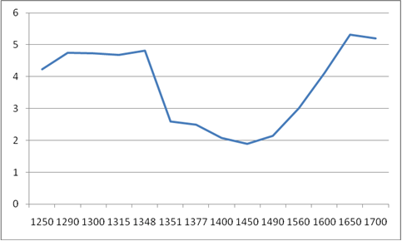
Y Axis
X Axis

Using Source 3,answer the questions.

23. The population of Europe __________________ as a result of the plague.
a. rose
b. fell
c. fluctuated
d. remained largely the same

24. It took _____________years for the population to return to pre-plague levels.
a. 77
b. 927
c. 877
d. 277

25. Which statement best describes the population trend in Source 7? The population
a. was fairly steady then went into rapid decline, then slowly recovered
b. went up and down
c. was in decline then rose sharply, then declined at the end of the era
d. was a smiley face

26. What two labels are missing from the graph (from the X and Y axis)?
a. X = Population In Years, Y = Millions
b. X = Plague Victims in Millions, Y = Months
c. X = Years, Y = Population in Millions
d. X = Twenty Four Hour Time, Y = Number of Deaths

Source 4
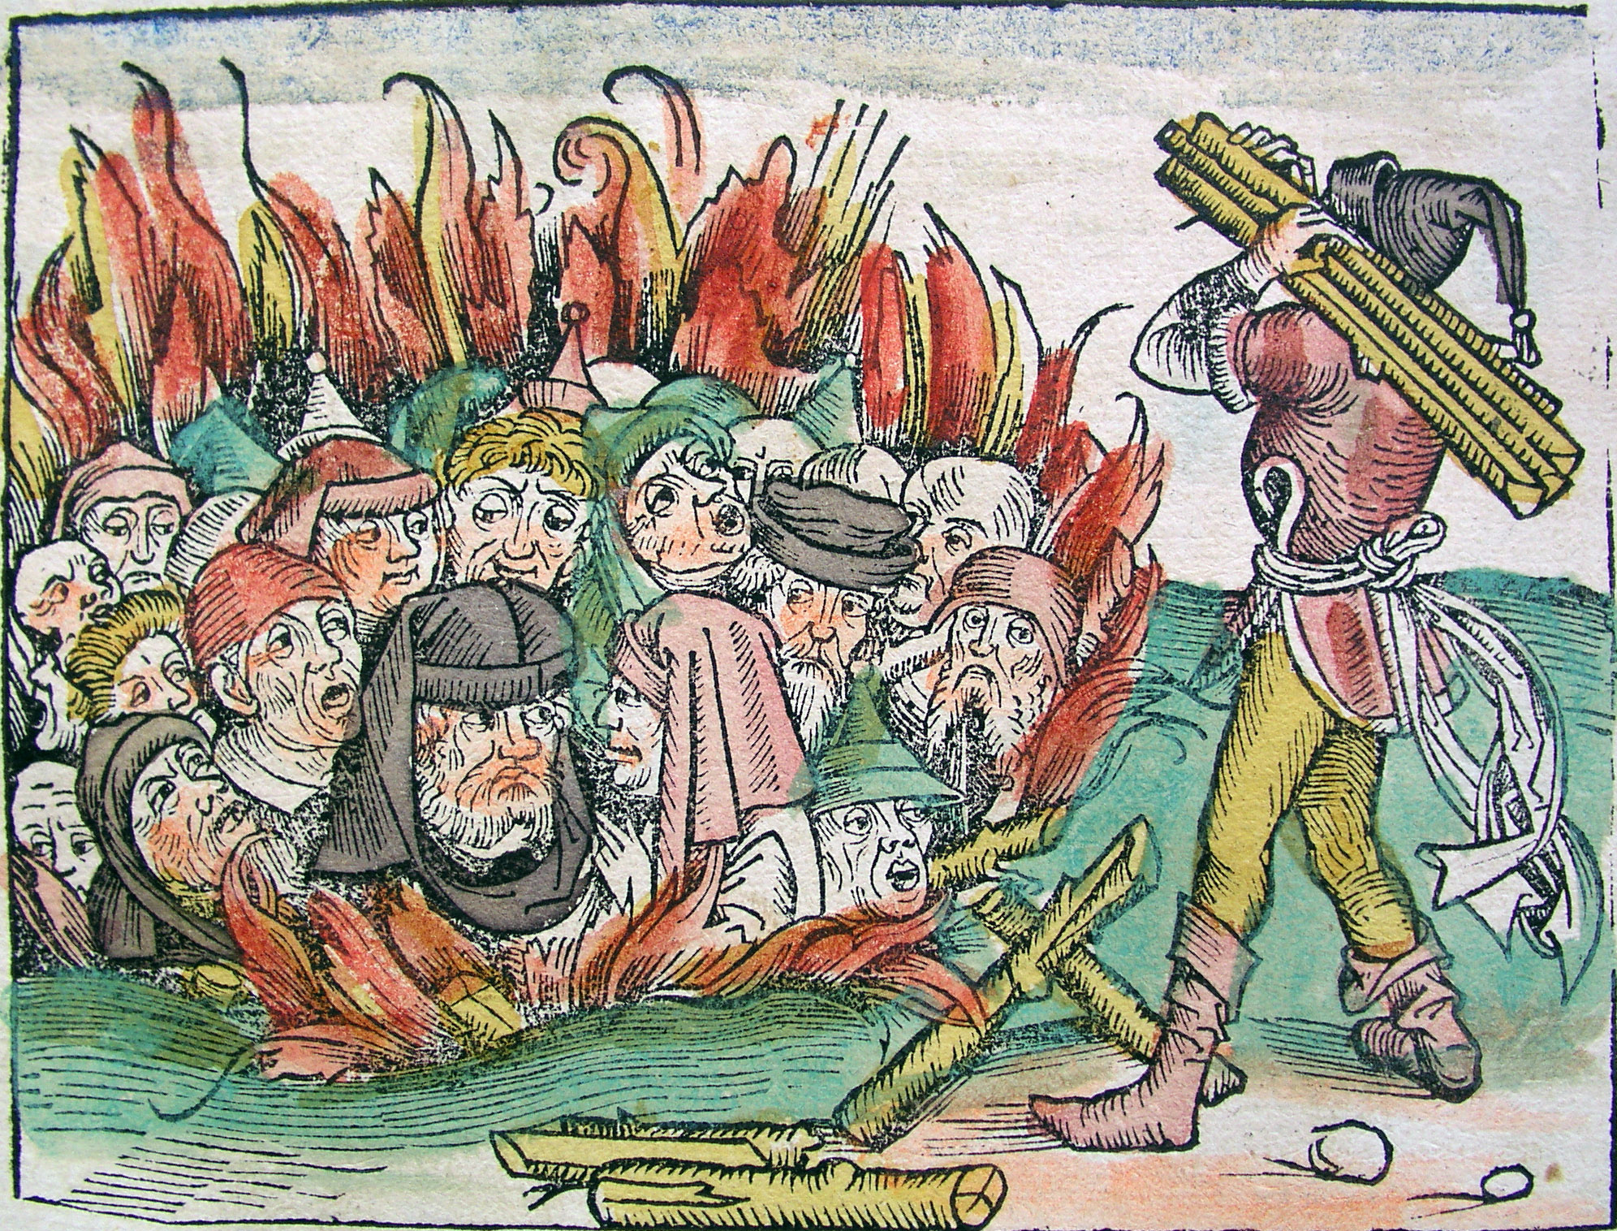
Burning of the Jews from Boccaccio, Giovanni, 1353.

The Catholic Church believed that the Jews had poisoned the water wells. This was because the Jews did not use the water from the public wells, considering their religious obligation to be ritually clean. 60 large and about 150 smaller Jewish communities were completely destroyed and thousands of Jews were burned at the stake.
(from http://deathblack.wordpress.com/category/influence-on-society/ )

27. Source 9 explains that
a. the Catholic Church blamed the Jews for the plague
b. Jews blamed the Catholic Church for the plague
c. both a & b
d. neither a nor b

28. One of the reasons that the Catholic Church may have blamed the Jews was that
a. the Jews were unclean and needed to be cleansed by fire
b. the plague had to have come from somewhere
c. the Jews were well known for poisoning drinking wells and should be scapegoats
d. the church was trying to make scapegoats out of the Jews because they were different

Use source 10 to answer the following questions.
Source 5 - I BURIED MY FIVE CHILDREN WITH MY OWN HANDS
The mortality in Siena (Italy) began in May. It was a cruel and horrible thing; and I do not know where to begin to tell of the cruelty and the pitiless ways. It seemed that almost everyone became stupefied by seeing the pain and it is impossible for the human to tongue to recount (means to ‘tell’) the awful truth. Indeed, one who did not see such horribleness can be called blessed.

The victims died almost immediately. They would swell beneath the armpits and in their groin and fall over while talking. Father abandoned child, wife, husband, one brother another; for this illness seemed to strike through breath and sight and so they died. None could be found to bury the dead for money or friendship. Members of a household brought their dead to a ditch as best they could without priests, without divine offices. Nor did the death bell sound and in many places in Siena, great pits were dug and piled deep with the multitude of dead. They died by the hundreds, both day and night and all were thrown in those ditches and covered with earth. As soon as those ditches were filled, more were dug and I Agnolo di Tura…buried my five children with my own hands…and so many died that all believed it was the end of the world.

By Agnolo di Tura writing about the plague of the 1300s

29. The author Agnolo di Tura, was traumatised by his experiences during the plague, which words / phrases from the text indicates this?
a. one brother another, divine offices, great pits
b. horribleness, Father abandoned child, end of the world
c. illness seemed to strike, bell sound
d. mortality in Siena, both day and night

30. Source 10 reveals that plague victims were
a. piled up high
b. left in the street
c. thrown into ditches
d. buried with his children

31. Agnolo di Tura says that people who never saw the plague
a. were blessed
b. were dead
c. could not tell of its horribleness
d. were pitiless

32. Agnolo di Tura would have been ___________ by his experiences.
a. devastated
b. tired
c. surprised
d. annoyed

